**What is meerkat III HPC?**

HPC is a collection of interconnected computers. Each computer is called a ‘node’ and these communicate with each other via an extremely fast network.

While a standard computer generally has 2 or 4 processors, the HPC has a lot more which allows substantial use of parallel processing (i.e. multi-tasking). That way, many separate tasks can be run simultaneously, or one massive task can be run in a reasonable time by splitting up the workload across many processors.

A personal computer usually has four to sixteen gigabytes of RAM, which is fine for everyday tasks. The HPC is designed to enable fast analysis of big data sets by incorporating much larger RAM on each node

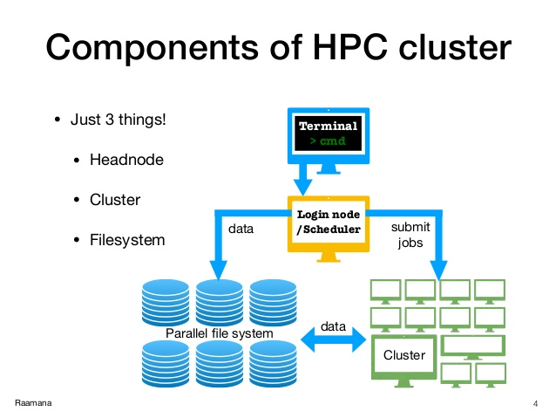

**How do I submit a job?**

First you will need to connect to the meerkat III HPC using the login node

For this use the instructions on this page :

<https://intranet.mcri.edu.au/KB/Pages/Information%20Technology/Linux/HowdoIconnecttotheMeerkatIIHPC.aspx>

In the Linux shell script:

Login as: your username

You will be asked for the password

Type pwd and check which directory you are in: you will always be dropped in to you home folder when you login. This is denoted by the ~ symbol near the end of your command prompt

This link has some more useful information:

<https://intranet.mcri.edu.au/KB/Pages/Information%20Technology/Linux/HowdoIusetheMeerkatIIHPC.aspx>

Some basic Linux command that will be helpful: <https://maker.pro/linux/tutorial/basic-linux-commands-for-beginners>

**pwd**- tells which directory you are in

**ls**- lists the files in the directory

**cd** -to change the directory

The jobs are submitted to the HPC cluster **using a pbs script**

A simple pbs script is shown below. Use a linux compatible text editor to prepare this ( I use Notepad++)

#!/bin/bash

##########################

# #

# The PBS directives #

# #

##########################

# Define the shell in which your jobs should run. Shouldn't really be changed

# unless you have a very specific reason for doing so

#PBS -S /bin/bash

# Define the name for the job

#PBS -N sim_sample_pvs

# Defining the wall time for the job

#PBS -l walltime=48:00:00

# Selecting which queue to send the job to

#PBS -q batch

# Defining the amount of memory you require

#PBS -l mem=4GB

# Defining email notifications

#PBS -m abe

# Define the email address to be used in correspondence

#PBS -M rushani.wijesuriya@mcri.edu.au

# Define the number of nodes and cores you require

#PBS -l nodes=1:ppn=1

# Define which project i am with

#PBS -A cebu

##########################################

# #

# Output some useful job information. #

# #

##########################################

echo ------------------------------------------------------

echo -n 'Job is running on node '; cat $PBS_NODEFILE

echo ------------------------------------------------------

echo PBS: qsub was run on $PBS_O_HOST

echo PBS: originating queue is $PBS_O_QUEUE

echo PBS: executing queue is $PBS_QUEUE

echo PBS: working directory is $PBS_O_WORKDIR

echo PBS: execution mode is $PBS_ENVIRONMENT

echo PBS: job identifier is $PBS_JOBID

echo PBS: job name is $PBS_JOBNAME

echo PBS: node file is $PBS_NODEFILE

echo PBS: current home directory is $PBS_O_HOME

echo PBS: temporary directory on node is $TMPDIR

echo PBS: PATH = $PBS_O_PATH

echo ------------------------------------------------------

module load R/3.6.1

cd /home/rushani.wijesuriya/HPC_tutorial

Rscript CCA_CATS.R

exit

Once you have created the pbs script, do the following

**1. Create a directory for your project within your home (H) drive.**

- Save your R script and pbs file in this project directory

**Within PUTTY/Meerkat:**

**2. Change the working directory to where you’ve saved your R script and pbs file.**

-Use the cd command

**3. Check that it worked by typing**

pwd

**4. Submit the pbs script: use**

qsub pbsfilename.pbs

**5. Check where it is in the queue**

qstat

Use qdel to delete the job if needed